TASK 3 PLOT THE FOLLOWING CHARTS FOR DATA VISUALIZATION FOR THE COLUMNS 'QUANTITY','SALES','CITY','SEGMENT','CATEGORY',AND 'ORDER DATE';

. A)SALES TREND OVER THE YEARS

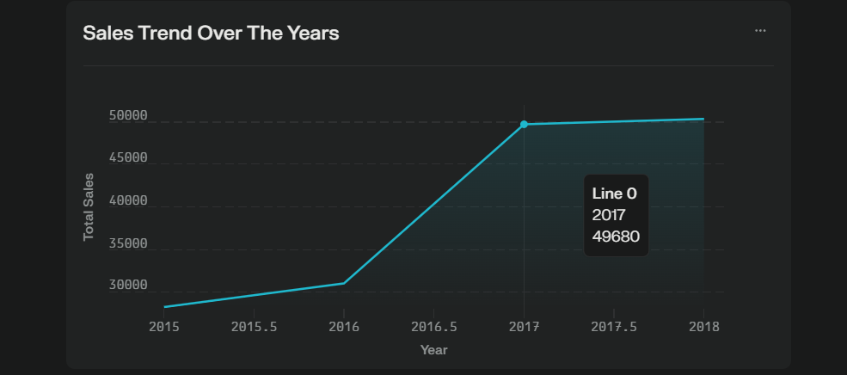

B) CITY -WISE SALES PERFORMANCE

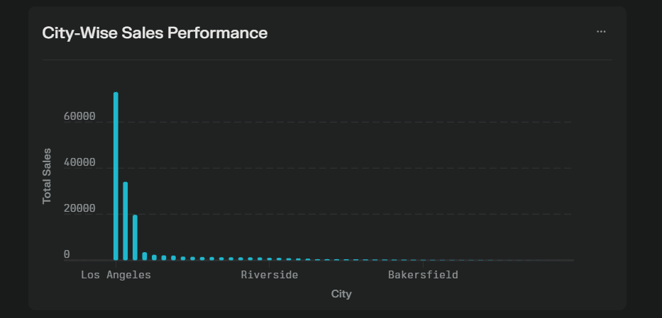

C) CITY -WISE QUANTITY ORDERED

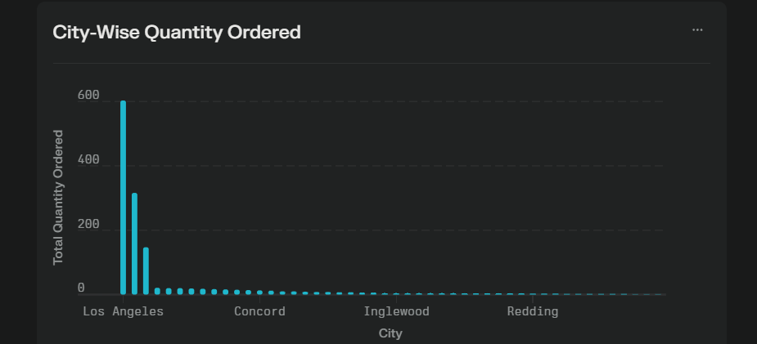

D) CATEOGORY-WISE SALES DISTRIBUTION

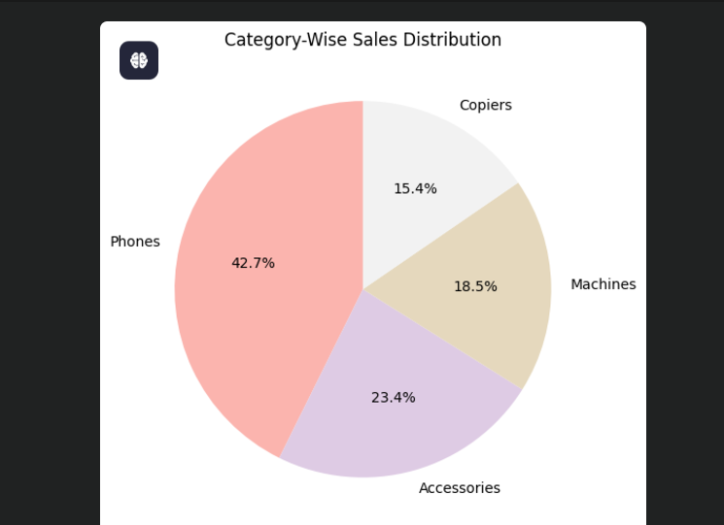

E) SEGMENT WISE SALES DISTRIBUTION

